Images from our Visit to the Middlebury College Astronomy Facilities – November 2017

On November 11, 2017, a group of folks from the Southern Vermont Astronomy Club, Keene 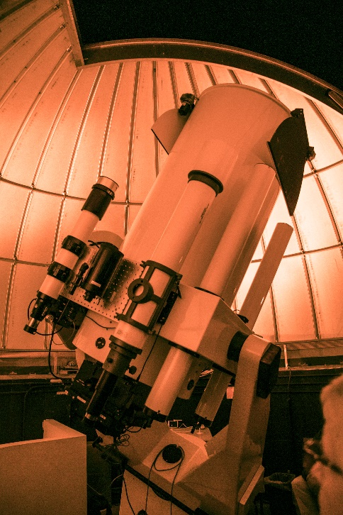Amateur Astronomers, and the KSC CALL program gathered in Middlebury, VT, to tour the astronomy facilities and other delights. Claudio Veliz nicely organized this day for us. After we gathered and satisified our energy needs, we headed to the Science Library where Wendy Shook, the Science Data Librarian, displayed the College’s fantastic collection of antique physics and astronomical instruments. We could have spent hours exploring the treasures.

Then we hiked or were elevated to the 7th floor of McCardell Bicentennial Hall where we viewed the facilities for the college’s astronomy program culminating in using the robotic 24” f/8 Ritchie-Chrétien reflecting telescope. Jonathan Kemp, Telescope and Scientific Computing Specialist gave us a detailed overview of how the observatory is being integrated into the college and Middlebury community life.

A very worthwhile experience.

And for the photos, click [Middlebury College - November 2017.](https://photos.app.goo.gl/FF3daTsbYzDFz7oJ3) You are encouraged to “Zoom”.